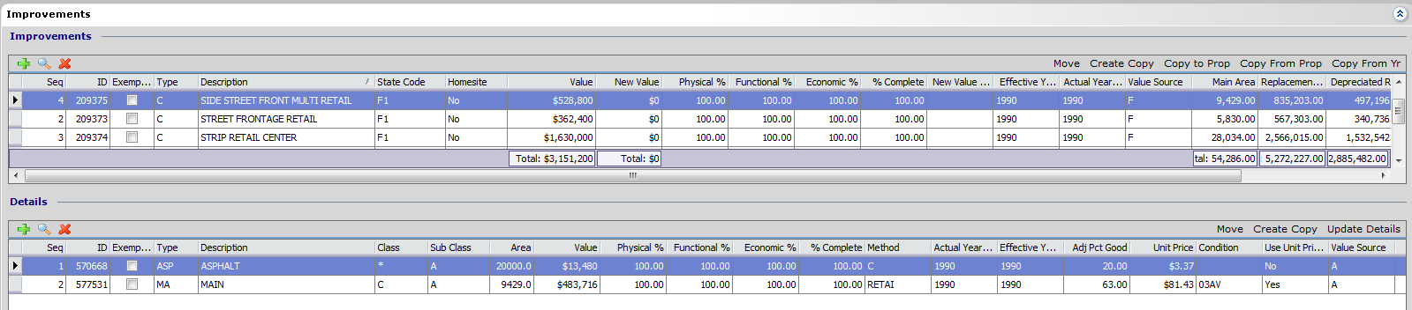

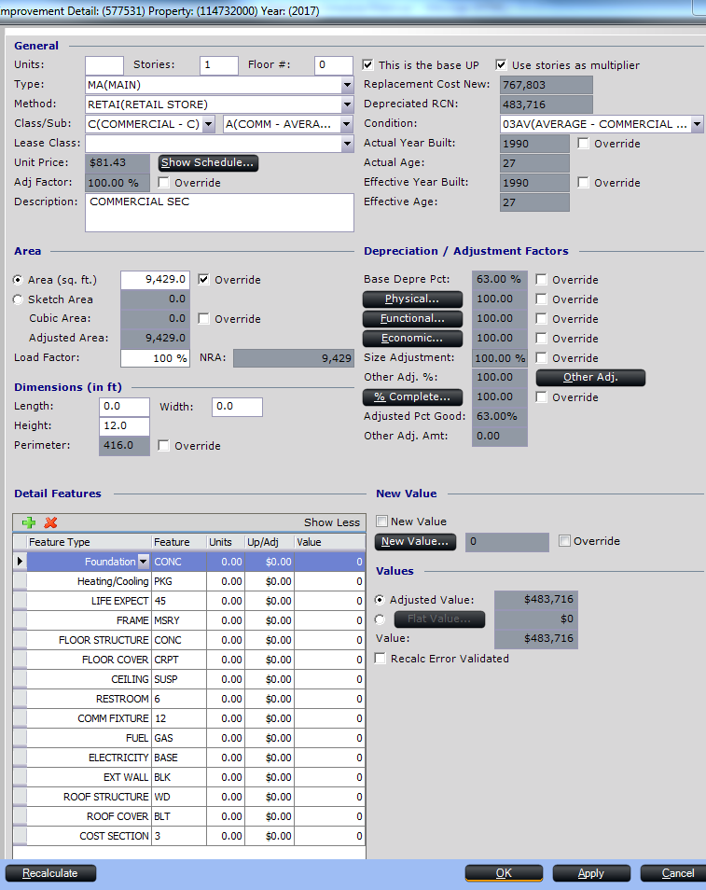As I had mentioned, a lot of the building description was in our prior system and we moved this information with migration.
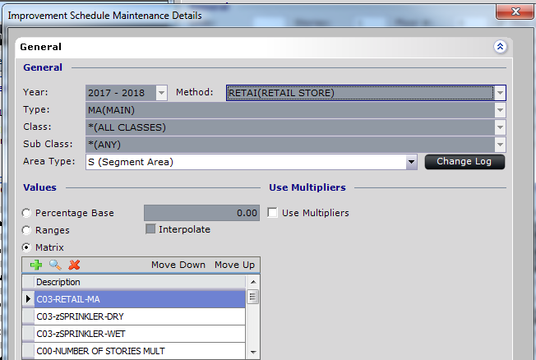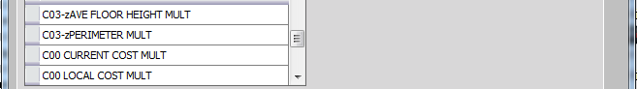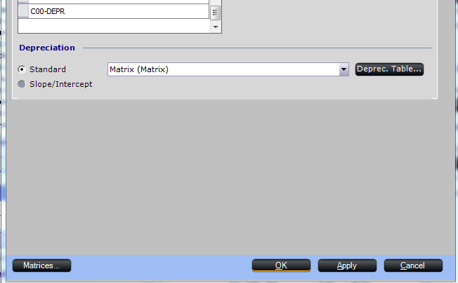
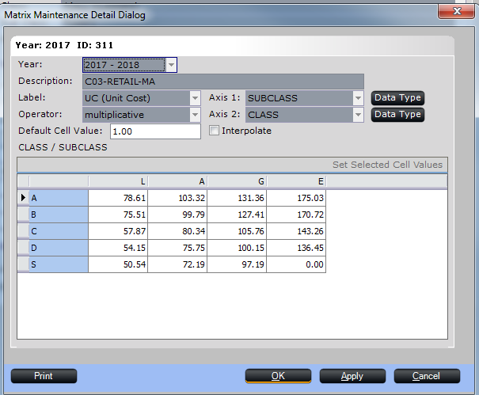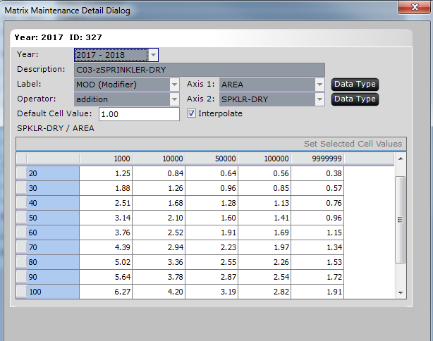
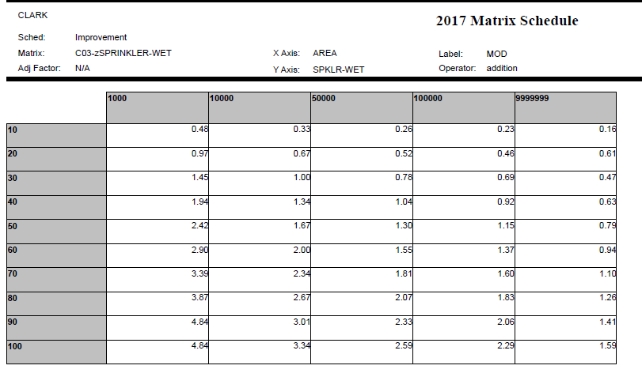
With the sprinkler matrixes I used percentage. If the building is 50% sprinklered it is the same net affect if I add 50% of the value to 100% of the building as 100% of the per square foot price on 50% of the building.
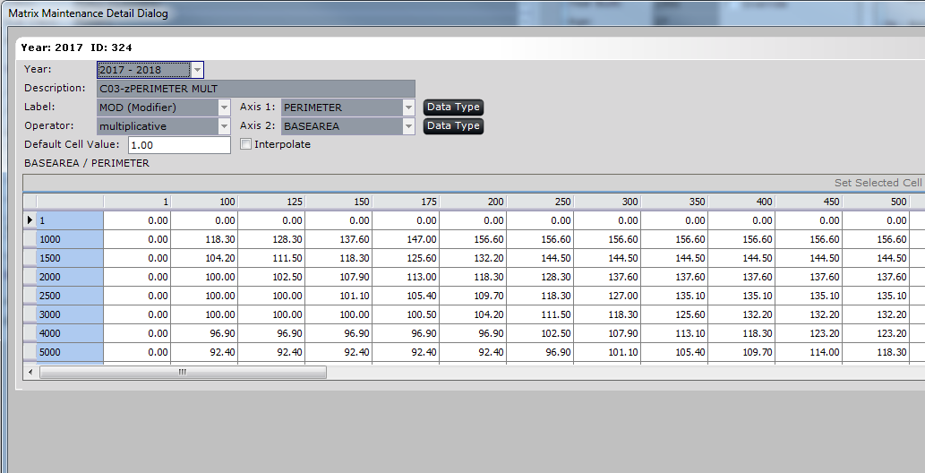
I chose to use a 0 multiplier for my beginning numbers. This will result in a zero value if these numbers are not put in? I realize that some of my staff are just looking for any number and may not notice right away if the number is just way off.
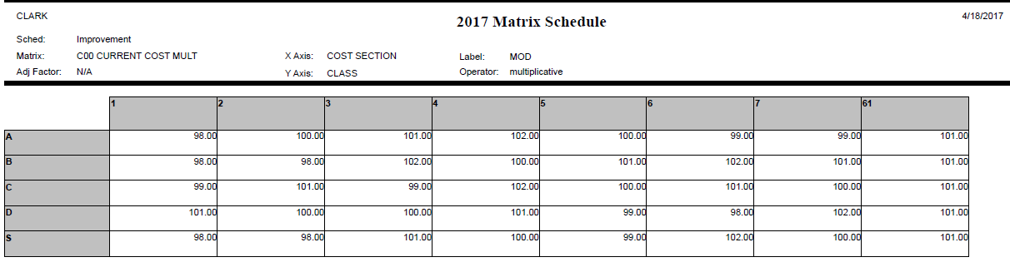
This matrix is from the green sheets of Marshall Swift addressing all the sections. Historically we have used 1-7 versus 11-17 like in the book.
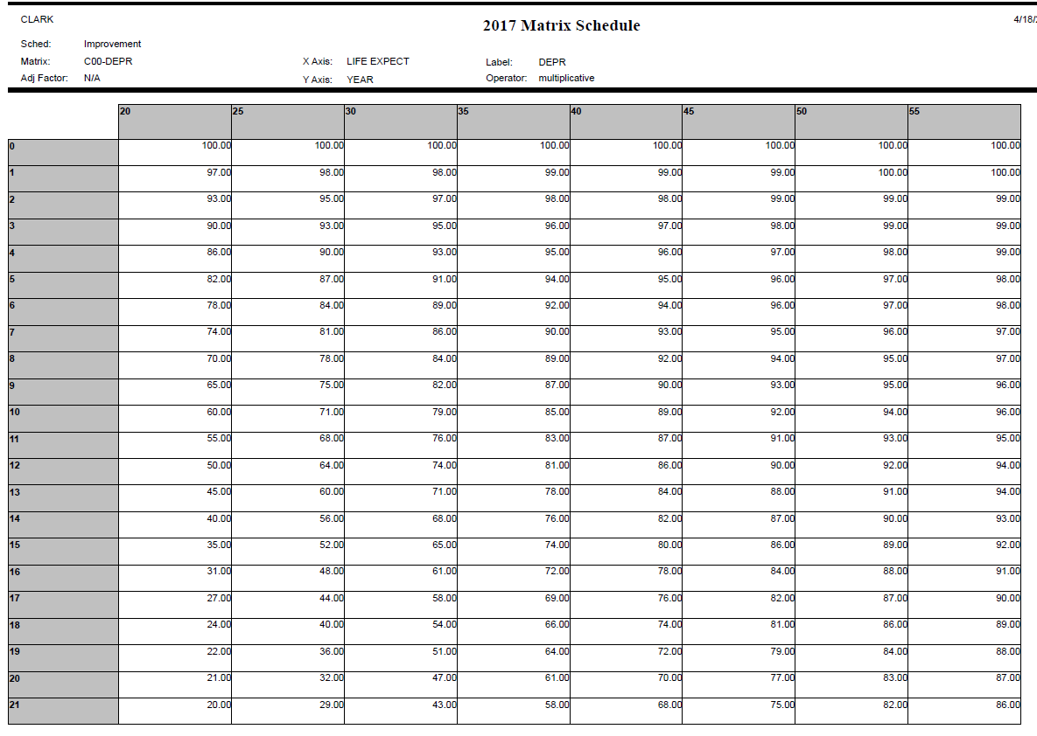
The depreciation schedule extends out further in economic life. The year is calculated by the effective age and I list the economic life as life expect as a detail feature line item. With each detail there is a drop down menu so I only load my available options.
This is on the same property, another building in which some of the costs are listed in the details. 